**Operating System**

**Lab Report 3**

**Hafiz Ahmad**

**19l-1316**

**Section-6A2**

System Calls

**INTRODUCTION:**

System calls provide the means for a user program to ask the operating system to perform tasks reserved for the operating system on the user program’s behalf. A system call is invoked in a variety of ways, depending on the functionality provided by the underlying processor. In all forms, it is the method used by a process to request action by the operating system.The most important benefit of a system call is simplicity. You should not have to write a complex program in order to open or save a file to the disk, or print a document. Further, you don't want to have anything become compromised in the operating system, such as device drivers or other system components.

Purpose of system calls….

* If a file system requires the creation or deletion of files. Reading and writing from files also require a system call.
* Creation and management of new processes.
* Network connections also require system calls. ...
* Access to a hardware device such as a printer, scanner etc.

**OBJECTIVES:**

• To understand about Linux system calls and their use in processes

**Application:**

If a file system wants to create or delete files, system calls are required. System calls are used for the creation and management of new processes. Network connections need system calls for sending and receiving packets. Access to hardware devices like scanner, printer, need a system call. System call provides the services of the operating system to the user programs via Application Program Interface(API). It provides an interface between a process and operating system to allow user-level processes to request services of the operating system. System calls are the only entry points into the kernel system.

**Issues:**

Face issue in problem 3 but soon its resolved.

**Conclusion:**

In this lab we learn about the linux system call and their use in processes and we also learn that how to use them in c file.

**Post lab:**

Q1

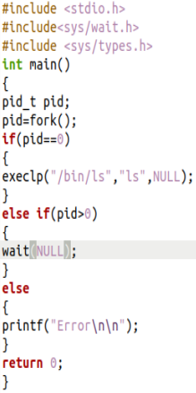



Q2.

